

Omiga .NET Project
Infrastructure Requirements Overview

Will Owen
Infrastructure, Architecture Team
1.3
07/11/2007

For Circulation to:

Name | Name
Name | Name
Name | Name
Name | Name
Name | Name

Contents
1. Requirement Overview 3
2. Artinsoft code release and connectivity into Vertex Networks. 4
2.1 Code Release Process 4
2.2 Artinsoft Infrastructure Requirements. 5
2.3 Network Connectivity. 5
2.4 FSD Connectivity Infrastructure 5
3. Desktop Infrastructure Requirements 6
4. Build Machine Requirements. 7
5. Vertex Test Virtual Machines. 8
6. SQL 2005 Datastore. 9
7. Load Test/Web/App/Ingestion Server. 10
8. Cost Summary 11

Requirement Overview
Omiga have a project proposed to migrate their current VB6 code base to .NET c#. The most cost effective method of achieving this has been identified through the use of an external software development company (Artinsoft) based in Costa Rica.
The aim of this document is to identify the technical infrastructure requirements for the project. Greater details of the requirement from Omiga can be found in the requirements document created by Adrian Stanley.

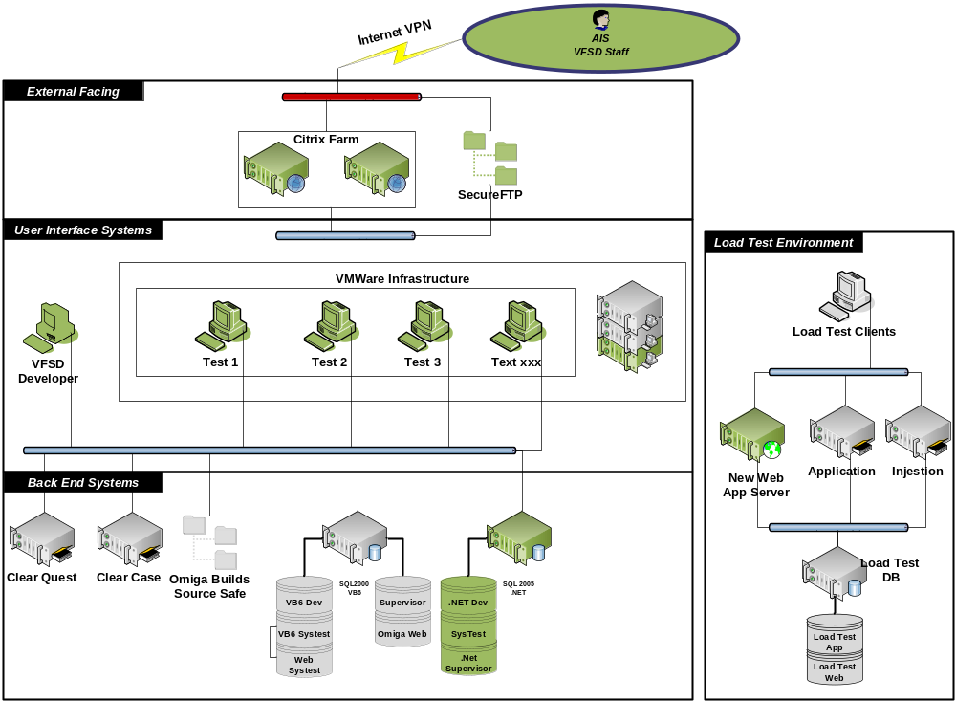
The above diagram provides a visual indication of the requirement. Items in Green are the new requirements and grey are existing systems they will integrate with.

Artinsoft code release and connectivity into Vertex Networks.

Code Release Process
The code management process (taken from Adrians document) is shown below.
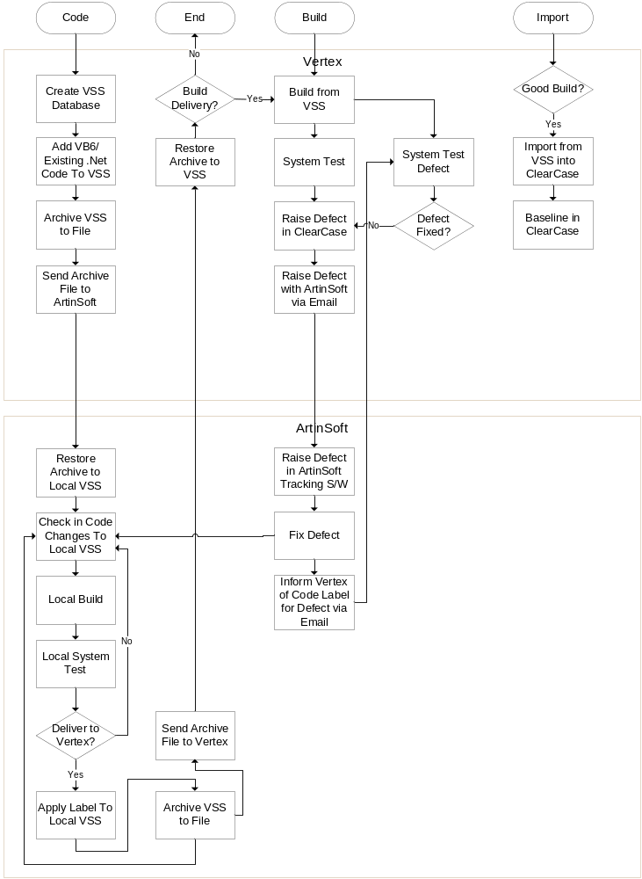

Artinsoft Infrastructure Requirements.
Artinsoft are required to provide all infrastructure, etc at their site to support the code development including software licensing, etc. They will also be required to provide network connectivity, etc for Vertex staff based at the site who will be working with them to develop and test the code.

Network Connectivity.
Artinsoft will provide internet connectivity to allow access the FSD citrix web portal and SFTP access to the FSD SFTP service.

FSD Connectivity Infrastructure
Provide Vertex staff (4) based in Costa Rica (NOT Artinsoft staff) access to the FSD citrix portal and publish.
- Email.
- Office
- RDP to the VMWare test environments.

Provide SFTP area and logins with 5GB of storage for code transfer between the 2 infrastructures.

Desktop Infrastructure Requirements
All desktops (x44) will be upgraded to the following specification where they do not currently meet it.
- WinXP SP2
- 2GB RAM
- Source Safe Client
- SQL CAL
- Office 2003 Pro.
- Visual 2005/2008 Pro (Version to be confirmed).
- Clear Case Client.

Details of the costs/numbers can be found in the cost summary section.

These desktops will not be backed up.

Build Machine Requirements.
2 desktops will be required to act as the code build machines. The specification is as follows:-
- Standard FSD PC with upgrade to 2GB and 250 SATA drive.
- Windows 2003 SP2 Standard Edition.
- Source Safe Client
- Visual 2005/2008 Pro (Version to be confirmed).
- Visual Studio 6 SP5
- Visual Studio 2003 SP1
- Clear Case Client.
- Final Builder 5
- Install Shield 2008 Pro.
These machines will not be backed up.

Vertex Test Virtual Machines.
These machines will be setup and utilised by the FSD team based in Cheltenham to test the code, with remote desktop connection for the FSD staff in Costa Rica. There will be approx 10 machines, and an ESX server, storage and licensing has been allocated in the cost summary.
The config of each VM Machine will be.
- Windows 2003 SP2 Standard

These machines will not be backed up.

SQL 2005 Datastore.
This server will be implemented with the following config.
- Hardware
  - HP DL585 G2, Quad Socket, Dual Core (8 processors).
  - 4GB RAM
  - 72GB local storage.
  - SAN Storage ~500GB.
- Windows 2003 SP2 Standard edition.
- Legato OS Agent.
- SQL 2005 Standard Edition.
The server will be backed up using the short store cycle (kept for 2 months).

Load Test/Web/App/Ingestion Server.

An Omiga application Server will be implemented with the following config.
- Hardware
  - HP DL585 G2, Quad Socket, Dual Core (8 processors).
  - 4GB RAM
  - 72GB local storage.
  - SAN Storage ~500GB.
- Windows 2003 SP2 Standard edition.
- Legato OS + SQL Agent.

The server will be backed up using the short store cycle (kept for 2 months). SQL Backups will not be taken automatically (these must be configured to backup locally).
In addition, the existing load test database server (SCH018668) will need licensing and installation for SQL Server 2005 Developer Edition.

Cost Summary
The total cost for infrastructure (including maintenance for software) is shown below. These costs do not include BTS implementation/support costs which will be provided on confirmation for solution and further analysis. Text in yellow is estimated (but reasonably close).
